Interfaces

What is an interface?

Ans: an interface is nothing but an abstract class which having no

concrete method in it. So an interface basically forces the sub class to override the abstract methods of interface.

As we use **extends** keyword to extend super class or abstract

Classes here in Interface we use **implement** to implement an

interface

classes are Extended but interfaces are implemented.

The purpose of implementing interface is to achieve

**Polymorphism.**

**\***When you extends a super class to sub class you can only extend only one class but with interface you can implement n number interfaces separating their names by ( **,** )

exmp <interface1> **,** <interface2>

*if you implementing an interface then you must have to override all the method of interface otherwise you have to declare the class as abstract

*when you override a method of interface make sure you make it as **public** (put public before datatype of method)

Otherwise it will throw an error.

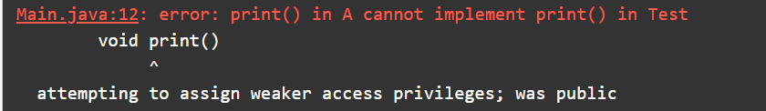

*You can not create an object of an **interface** but you can create a reference of it and can assign it to sub class’s object;

* *Data members of an interface are static final and abstract methods are allowed only
* *An Interface can also **extends** another interface

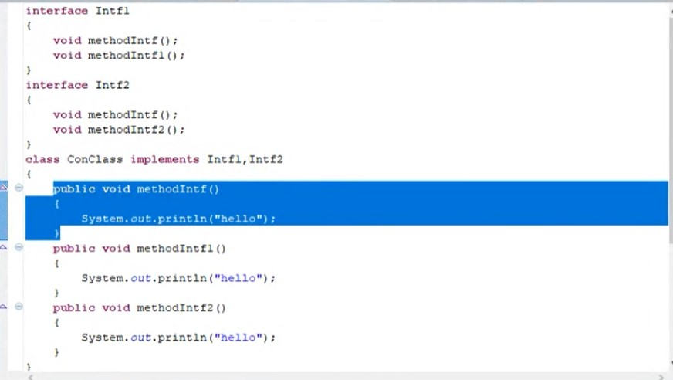*what if multiple interfaces having same methods and you implemented all of them

In this case all them methods of all interfaces will be called

So multiple inheritance can be implemented in java but only through interfaces not with classed because you can’t extend more than one class

**REMEMBER** When you implement an interface method, it must be declared as public.

**REMEMBER:** if a method is not defined inside interface you can’t call it through the reference of interface